AFM Room Temperature Water Matrix

# Introduction

This set of measurements is designed to yield important proof-of-concept information regarding the applicability of van der Waals theory to describing micro- and nano-particle adhesion to large substrates. My original claim in the quals presentation was that vdW is a dominant force underlying fouling – the reasoning behind this was that this force can be considered to be an ‘elementary’ force, like covalent and ionic bonding, thus it is a basic explanation for why larger scale adhesion occurs (however this precludes physical mechanisms like crystallization). Ideally the Lifshitz theory already accounts for surface charge and chemistry because the vdW force is not treated as emergent. I found readily available natural mineral samples (in the hopes that I would get a single crystal material), and tested their adhesive force to an SiO2 4um microsphere. SiO2 was chosen because it was a readily available, well characterized optically, and highly spherical microsphere material. 4um was chosen because of Reid’s experience with 4um spheres both leading to higher numerical forces and being less sensitive to nanoscale surface roughness than 1um spheres (which in turn were the de-facto standard following my work with the 3D nanoprinter).

In the subsequent months, I mounted and polished samples (to 3um diamond suspension, but definitely my lack of experience with the procedure caused surface to be much rougher), ordered SiO2 sphere probes, then set up the new AFM and began trials. Eventually I was able to have a procedure that allowed me to do all the measurements in one run with a single AFM probe. There were 11 materials total, evaluated with a single SiO2 probe (this was done for maximum consistency). The adhesion measurements were carried out in a droplet of distilled water. Adhesion was recorded in terms of nN with unity conversion from mV (based on quadrant photodiode FN readout in AFM software – this is the default operation mode), but these nN units are not absolute. I recorded the “difference between red and green traces at red minimum point” – the green trace, which is the approach trace, would serve as a local zero reference at the maximum adhesion point. This should ideally eliminate effects of interference noise present in rest of curve. The individual FD curves were not saved. There was not a consistent maximum applied force. Scan speed setpoint was 100 nm/sec, 100 msec wait time, 100 msec middle time, but I think in reality the AFM ran at a different speed. Despite the local spread in material measurements, this experiment led to a plot confirming the overall validity of the initial 11 materials compared to vdW predictions. The acceptable relative match across all 11 materials provided evidence that vdW plays a significant role in particle adhesion.

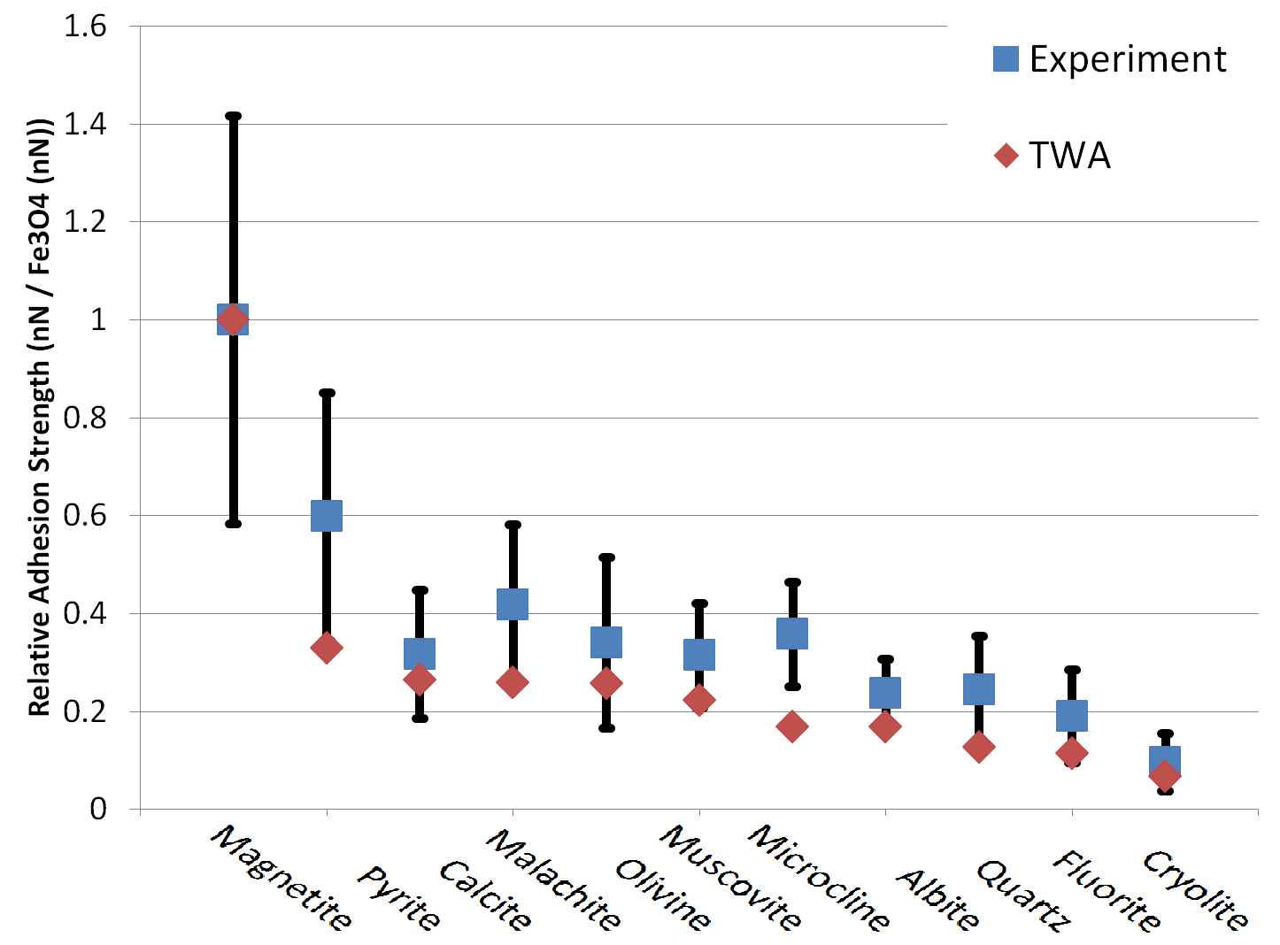

Also around the writing of the prospectus, Mike had the insight that if vdW theory applies, and the Tabor Winterton Approximation (TWA) applies, then matching the substrate material to water will reduce adhesion for all types of fouling particles. Naturally, the next experimental confirmation of this theory would need to test the adhesive force between different substrate materials and different microsphere materials, to ensure that changing the substrate to a lower index of refraction will lead to reduced adhesion for all microsphere-like ‘fouling particles’. The possible combinations of substrate material and microsphere material are easily expressed in a matrix, thus I set out to complete the AFM Room Temp Water Matrix.

# Experimental Procedures

Since the initial AFM measurements, I had better understood the value of keeping track of specific material details. Initially I referred to samples by the mineral name and did not have them labeled, using their appearance to distinguish them. The same thing happened with AFM probes. Somewhere along the way the probes used for the initial measurements went missing (or maybe just mislabeled). To avoid this situation again, I developed a label system for all samples, and a spreadsheet tracking samples and AFM probes. Probes are tracked by their unique numeric label, such as ‘Novascan 40’, and tracking is confirmed by checking their row/column ID which is etched on each probe. The highest observed so far R and C numbers or 15 and 21 give 435 possible combinations, which along with the sphere appearance may even be enough to identify a misplaced probe.

Experiment log text files are used to keep track of observations during the experiment. Files and experiments are split by periods when the AFM is turned on or off. In a single experiment, the AFM remains on continuously. In the log files, samples and probes are referred to by their labels, not mineral names or other names. The material names and compositions are found by looking up the labels in the sample tracking spreadsheet and AFM probe tracking spreadsheet. Temperature and room humidity conditions are recorded throughout experiments to ensure that no sudden changes occur.

There were also changes in physical parameters based on continued experience with the AFM. The AFM is warmed up for 30 minutes to prevent measurement drift due to laser diode temperature change. From Buket’s demonstrations, I learned that a much faster scan speed setpoint can be used – it is 2000 nm/sec in the matrix measurements (again I do not believe the AFM actually moves this fast, based on time taken to acquire data). An attempt at an absolute force measurement is made by carrying out an FD measurement on a hard SiC polished substrate which is used to determine probe sensitivity (slope of the upward sloping line once the probe has touched the surface – recorded in nm/mV). The sensitivity is determined by probe mechanical alignment and laser power, so this measurement needs to be carried out with each new probe or laser setting change. With such a large microsphere, it is not strictly necessary to use SiC (the upward sloping part of the regular FD curve can be used instead), but it is done here as the SiC provides a convenient ‘standard’ measurement. DI water is kept in an ethanol-cleaned and DI water-rinsed glass flask, covered with a glass stopper. The DI water will absorb CO2 over time and become non-DI, which is not taken into account (fresh DI water is not used in each trial).

The start and end point for probe measurements are set such that the maximum applied force is in the range of 0.0100 to 0.0200 mV. Ideally this should be kept as a constant absolute force value, obtaining the mV value to track by back-calculation. The 0.0150 mV value was chosen as it was a typical observed adhesive force on the SiC substrate – if the sphere is capable of this much adhesive force, it is reasonable that it will withstand this much applied force without excessive deformation. This value was also easy to read during measurement as typically it was 1-2 orders of magnitude larger than noise floor.

I also observed that on some samples the green trace (approach curve) had a ‘dip’ on approaching the sample, meaning recording the difference between red and green traces (as was done in initial measurements above) would be inaccurate. Instead here the average of the red trace ‘flat section’ or ‘non-contact section’ is used as a zero reference for the lowest value of the dip that represents the adhesive force. This is still far from ideal, as large scale noise is present in many measurements that makes it difficult to establish such a baseline. In the majority of scenarios, the point on the red curve to the left of the ‘dip’ that is closest to intersecting with the green curve is taken as the baseline. Then the difference, in mV, between the baseline and the lowest point of the dip is recorded. In some instances the lowest point of the dip can be clearly identified to be a high frequency noise artifact, in which case the visually-determined most likely lowest point is used for the recorded value. All plots are saved to allow for later analysis or re-calculation of the adhesion values. Each plot file contains a number of individual FD plots taken at nominally the same point (slight differences will occur due to in-plane probe motion as it is raised and lowered over a reasonably large distance). In the majority of cases, the last four plots of the saved file are recorded as the experimental measurement in the spreadsheet. Exceptions are made when the last four plots do not all have the acceptable ~0.0150 mV applied force such as with a drifting sample, or when noise makes some of the plots unreliable.

To ensure accurate results, the probe row/column values are visually verified before and after loading, as are sample numbers. Additionally the presence of the microsphere on the probe along with cleanliness of the cantilever and microsphere are visually verified after each measurement by placing the entire AFM under an optical microscope. This necessitates a brief (2-3 minute) interruption of laser power, which is assumed to not be an issue in terms of thermal and other operating properties that might affect the sensitivity.

## Detailed Procedure

1. Begin by warming up AFM for 30 minutes (to get equilibrium temperature) - all lights and laser on. Software and optical microscope camera window should be open to establish communication (this will maintain a consistent heat load on the ICs in the AFM). DI water and samples should also be in same room to reach same temperature. Fill syringe with ‘fresh’ DI water from glass flask.

2. Place samples, uncovered, and AFM probe, in snap cover, under DI fan for 10 minutes

3. Check probe serial (R/C number etched on it) matches what should be used. Install probe on dry AFM platform. Check presence of microsphere under microscope. Add three drops of water to scanner platform (just enough to cover entire probe for proper laser path), check that probe is now visible in camera image. If necessary, make laser alignment adjustments by loosening the three screws on the outside of the platform and moving the platform into position. Any operation with the AFM scanner flipped upside down should be quick to reduce amount of water leaking into AFM through bolt thread holes. Use the three screws holding platform in place to adjust the platform until the 'Probe Indicator' in the software shows a green checkmark then secure all screws tightly enough for continued measurement. Do not loosen the two screws holding the probe in place since that will let water leak through into AFM and will also let the probe float upwards in the water droplet and rub on the plastic and get damaged (and finally due to the kinematic mount adjusting these has little effect).

3a. Place SiC calibration sample on AFM stage. AFM must be raised beyond 5.5mm height (raising and lowering must be done with the AFM properly oriented – not upside down!). Use blue plastic guide to ensure centering of sample. Record room temperature and humidity. Add DI water to top of sample. Place scanner in position on top of sample, and approach until image of probe is visible on camera (indicating a continuous water droplet formed between scanner platform and sample).

4. Perform a Null FN (click thrice), then auto-land, click approach once, and do FD measurement of SiC sample.

4a. Initial FD range should have starting point as tip position + 800 nm and ending point as tip position + 300 nm. Range must be set to ‘Fixed Range’, otherwise slope of plot will change when range changes. After that, range end point is adjusted using up/down arrow keys so FD measurement has maximum FN (measured between the non-contact voltage and the maximum voltage, not just the highest value on the axis labels) of 0.0100-0.0200 centered on 0.0150 for consistency. All FD measurements are at 2000 nm/sec rate with 100ms middle wait time.

5. Ctrl+click on two linear points on the resulting curve to get a photodiode sensitivity measurement, dependent on probe installation and laser power. Do this on four different plots (from the same physical location on substrate) to get a range of values. Record this as nm/mV.

6. Record measured adhesive force, as difference from min of retract curve to next closest max. Record this force in mV, get four values from the same physical point. If no clear min or max exists, still record the appearance of plots in the log. Export the plots data for future reference.

7. Retract AFM head using the motor control slider and dry out water on AFM scanner using a kimwipe tissue and making sure to not touch probe tip. Place scanner under microscope and check for presence of microsphere (without removing probe).

7a. Load new samples. Secure new samples with external magnets as necessary. Use blue plastic guide to ensure centering of sample. Record room temperature and humidity. Add 3-4 droplets of water to AFM scanner platform, ensuring the cantilever is inside the resulting droplet. Flip the AFM scanner upside-down in such a way that the droplet does not flow off the platform (a motion like flipping pancakes). Place AFM scanner in position on top of samples, and approach until image of probe is visible on camera (indicating a continuous water droplet formed between scanner platform and sample).

8. If FN reads more than +-0.003 V, perform a Null FN (click thrice). Auto-land probe on sample surface, capture photo of material (once per sample; if not focused adjust focus to approximately 30.99), click approach once, and perform FD measurement of sample. Set range as in step 4a in order to maintain constant maximum FN of 0.0100-0.0200 centered on 0.0150.

9. Continue FD data collection until four plots with max FN in acceptable range have been obtained. Then record adhesive force (in mV) - difference from min of retract curve to next closest max - from these four plots in the experiment log. If no clear min or max exists, still record the appearance of plots in the log. Export all plots for reference.

10. Click retract four times to move probe far from sample surface. Use Motor Control XY window to move sample to next location. Use 100 um setting with medium speed. On even samples, use only X+ and Y+ controls. On odd samples, use only X- and Y- controls. Click one of the arrows once to move to a new 'random' location.

11. Continue to 8 until the desired number of data points for this substrate material has been collected.

12. Continue to 7 until the desired number of substrate materials has been tested.

13. New probe: place new probe (in snap cover) under DI fan, dry AFM platform (otherwise probe will float to surface and break!), check for microsphere presence on old probe, remove old probe to its original labelled storage and confirm probe serial (the number etched on it) matches probe that should have been used. Continue to step 3 until desired number of probes has been used.

# Experiments Overview

For this study, experiments were numbered sequentially starting from Experiment 100. Experiment 100 did not follow above procedure as it was an attempt to make a reliable procedure.

Each experiment measured some combination of probes and substrates. The experiment in which each combination was carried out (up to E113) is given in the following table (and in the Experiments and Probes spreadsheet):

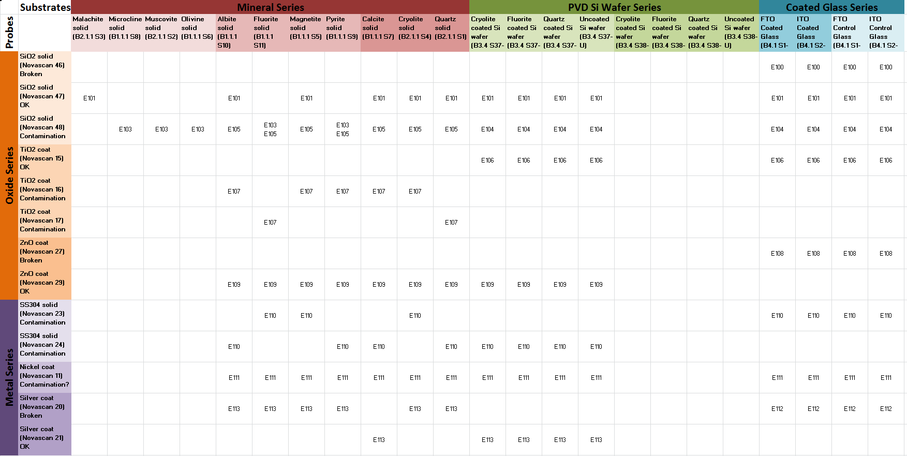

As can be seen, even though a number of probes has been used, there are actually few ‘identical’ measurements in which the same probe and substrate have been measured. These comprise only two substrates in the early SiO2 experiments E103 and E105, and comparing those results shows very favorable agreement. Further agreement needs to be established in subsequent passes of the matrix. This is made more difficult by broken probes. Best success has been achieved with the Nickel coated probe, of which only one had been used. Worst success was with TiO2 of which three have been used (dust particles seem to make their way to the TiO2 microsphere). All probe materials have at least two remaining good probes for subsequent passes of the matrix.

# Errors

An ideal textbook F-D curve would have a ‘triangular’ shape as in the following examples, where the triangle has been outlined for reference:

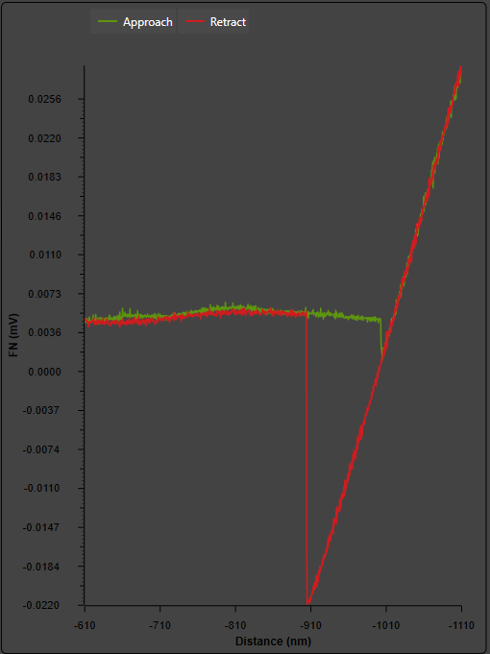 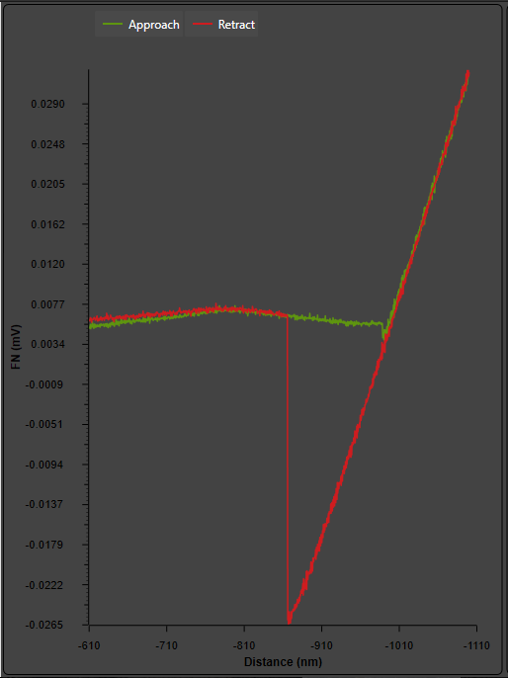

The vertical side length of the triangle represents the maximum negative force felt by the cantilever as it is pulled back from the substrate at the retract stage. The y-axis of these plots is in [mV] representing the quadrature photodiode reading of cantilever deflection in the first beam bending mode, while x-axis is in [nm] (pre-calibrated by AFM manufacturer based on voice coil actuator response) representing up-down movement of the base of the probe. By knowing the slope of the hypotenuse of the triangle on a hard substrate (SiC is used in these experiments for reference, but in theory the actual hypotenuse in F-D plots can be used just as well), keeping the exact same laser settings and probe alignment, a conversion from [mV] to [nm] is possible. For instance I find that on a hard substrate a downward movement of 5 [nm] yields 1 [mV] laser deflection, so a subsequently measured highest-adhesion point of -2 [mV] corresponds to -10 [nm] deflection of the probe before it breaks free from adhesion. Further knowing the spring constant of the cantilever, measured either by thermal methods, by mass-added methods, or by the manufacturer-supplied value (latter has been used for this matrix), allows converting the [nm] deflection to [nN] force at the tip. This is the method used to calculate adhesive force in the matrix.

Unlike an ideal F-D curve plot, the matrix measurements had significant deviations from the expected triangular shape. The deviations are classified into five major types: LF (low-frequency noise), HF (high-frequency noise), divergent (approach and retract curves do not meet at the starting point), smooth (no clear ‘point’ of triangle), dual dip (two triangles or triangle+rectangle can be drawn). Finally a comment on the noise floor is included.

## Low Frequency

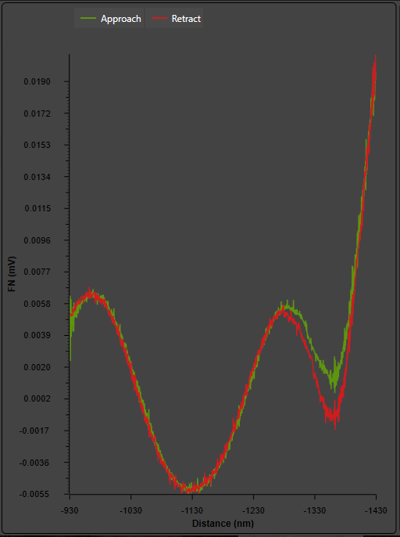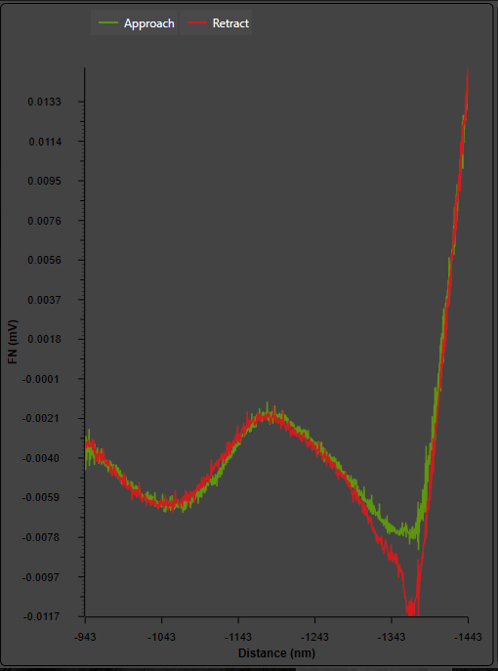

The low frequency noise occurs on the non-contact ‘flat line’ portion when the probe is either approaching or retracting from the substrate. It is always in-phase on both curves, suggesting that this is not due to external vibrations but due to the mechanism of the AFM itself. The main difficulty it poses is in defining the non-contact ‘zero force’ reference from which to subtract the ‘triangle point’ value. Normally I use the value where the approach and retract curves meet closest to the ‘adhesion dip’, but this is certainly not the most accurate approach.

Low frequency noise is most likely caused by bubbles and angled/lens-like reflective surfaces on the sample. The reflected laser light from these features can either strike the photodiode at arbitrary spots to cause the average ‘center’ reading to shift as a function of probe height, or it could cause interference fringes to move across the photodiode leading to the same effect. The period is not constant, so it is not purely an interference phenomenon.

## High Frequency

High frequency noise consists of short ‘bursts’ that are most visible on the non-contact segment but persist through the contact segment as well, just not being as visually apparent. They don’t pose much difficulty except for samples with very low adhesive force, where they increase the noise floor and increase the smallest resolvable force.

High frequency noise is likely caused by electronics, either pulse sources within the AFM coupling to the reading, or RF leaking through connectors or unshielded traces. HF noise was also observed when operating with poor vibration isolation (since here HF is on the order of 10-100 Hz), so some of it may come from mechanical pulse loads from nearby pumps.

## Divergent

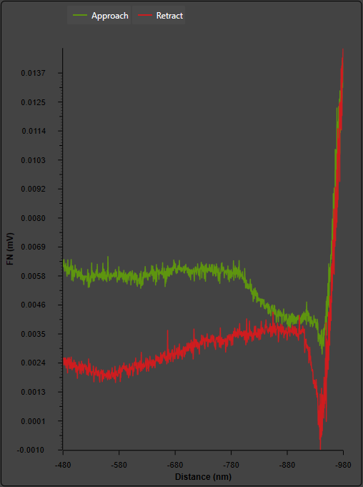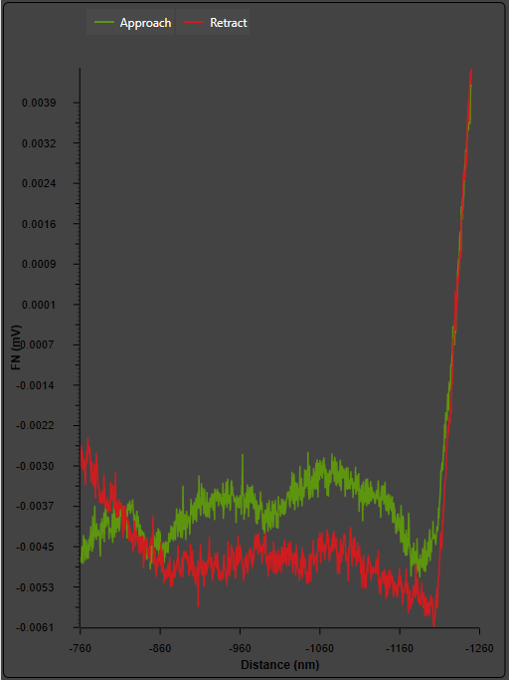

Divergent noise results in plots where the non-contact zero-force region where both the approach and retract curves are expected to overlap actually has no or minimal overlap. It is very questionable to use plots like this for adhesion force measurements as there is no clear zero point.

Divergent noise was seen to come from vibration of the connector between controller and cable to scanner head. It was also seen when the substrate was loose or there were floating particles (including bubbles) in the water – for instance this occurred with the fluorite coating which peeled off during measurement resulting in floating patches.

## Smooth

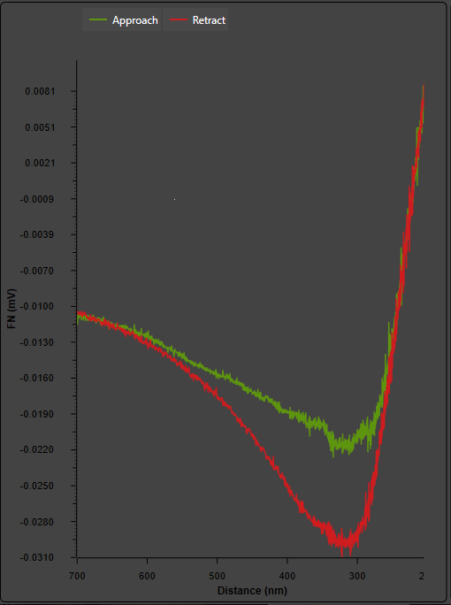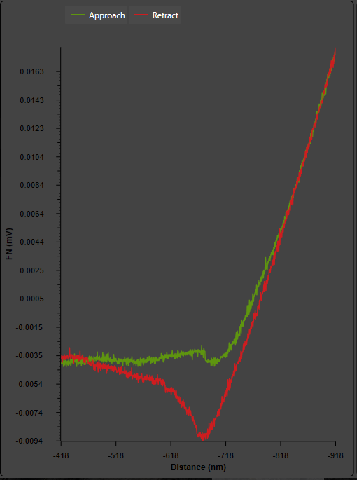

Smooth curves did not have a clear triangle shape, but rather more of a harp shape where the nominally flat non-contact region becomes curved. There is no clear zero force reference, so defining an adhesive force becomes difficult and unreliable.

Such curves may be due to substrate motion during measurement or may also be a much lower frequency version of the LF noise effect. If the substrate ‘floats’ in a layer of water, the probe may exert enough downward force to push the substrate, and the substrate is pulled back up on the retract curve well beyond the point where it should have separated. If the scanner head is creeping downwards (or the substrate upwards), a similar effect occurs.

## Dual Dip

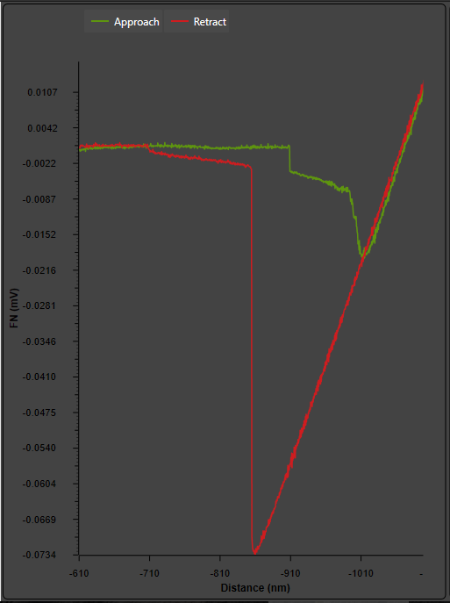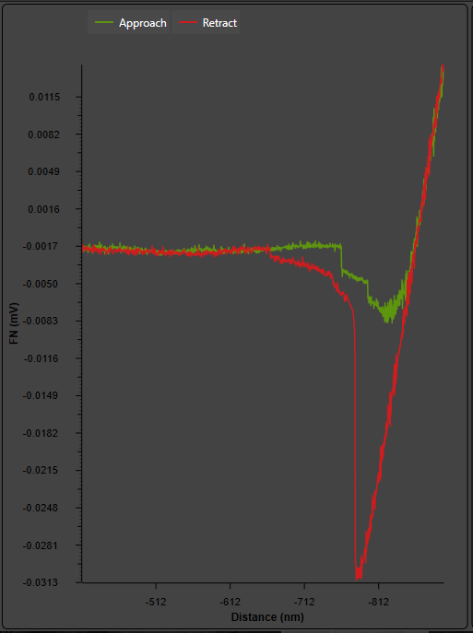

Here two ‘regimes’ seem to take place, one causing a dominant adhesive force that makes a clear triangle shape, while the other acts at longer distance causing a jump farther away from the nominal adhesion release point. Normally this dual dip behavior is seen on both the approach and retract curves.

At this point I don’t have a good explanation for this type of noise; it may be an actual physical effect. In case of this noise I am still able to calculate the adhesive force in the standard way, using the part of the plot where the approach and retract curves overlap as the zero-force reference.

## Noise Floor

Since the goal of the experiment is to measure some adhesion-resistant coatings, it may be expected that at some point the adhesive force may be so low that it will not be visible in the noise. HF and LF noise exacerbates the noise floor, and usually any forces below 0.5 mV will not be visible.

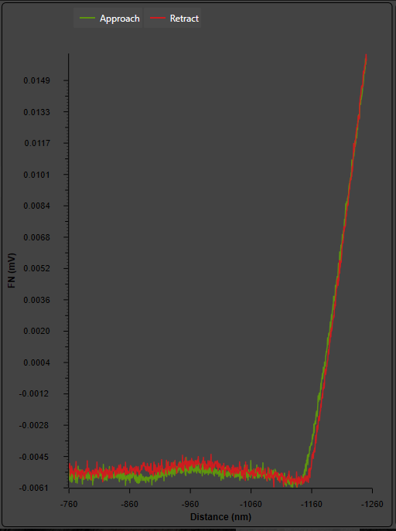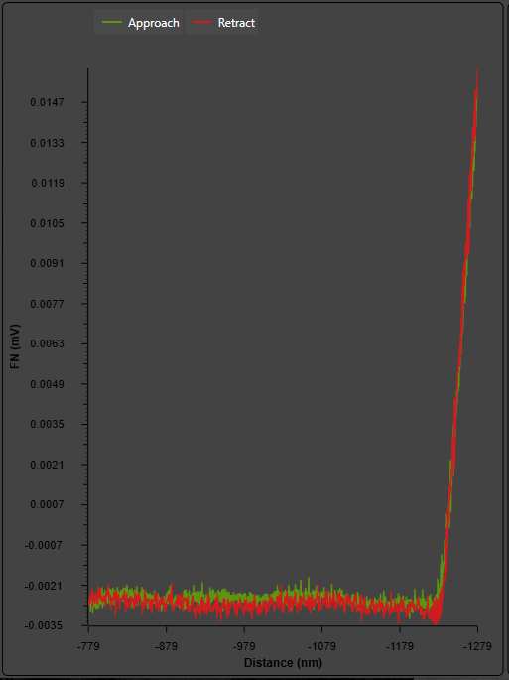

Sideways deviations of the approach and retract curve may be explained by a ‘drifting’ sample, which in reality may be either due to slight thermal variations, creep of scanner head downwards/upwards, or water surface tension pulling the sample or individual minerals embedded in epoxy (since the epoxy ‘pocket’ containing the mineral is not liquid-tight there may be just enough room for water to enter and cause motion). While the ‘drift’ of samples is extremely common, sideways displacement of the curves is not observed often – perhaps because the speed of the F-D scan is usually faster.

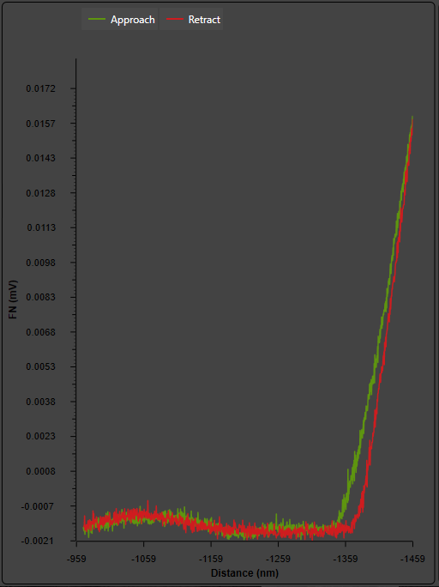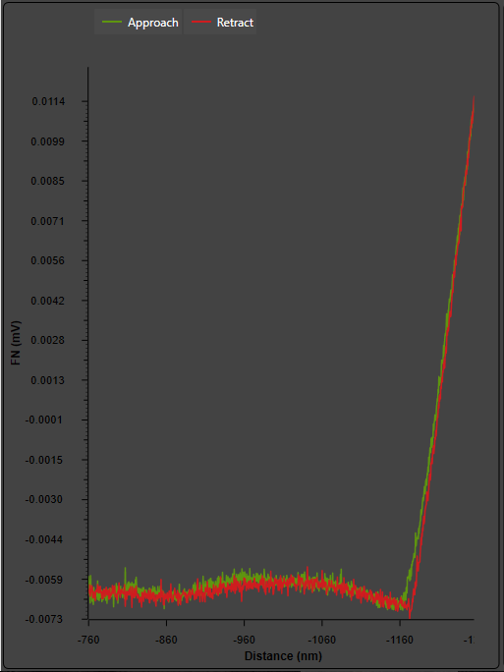

## Proposed Approach

It is noted that in most types of noise, there is difficulty in determining the exact zero-force level and maximum-force level. Yet most types of noise affect both the approach and retract curves. Thus a few suggestions are made:

1. Minimize bubbles by using distilled water and a highly polished flat surface (which will not trap air or cause unwanted laser reflections)
2. Securely attach all substrates, ensure that epoxy bond is leak-tight and solid (no ‘cantilevered’ samples – they vibrate during measurement!)
3. Securely attach samples to base, otherwise water tension will tend to pull samples in both XY and Z directions (only a few microns, but enough to upset measurement data)
4. Instead of calculating the adhesive force, calculate the work of adhesion. This is the integral of the difference between approach and retract curves (E=F*dx), and is thus insensitive to any in-phase noise. Its application to smooth and dual dip curves is questionable, however, and sensitivity to HF noise needs to be carefully considered.

# Observed Trends

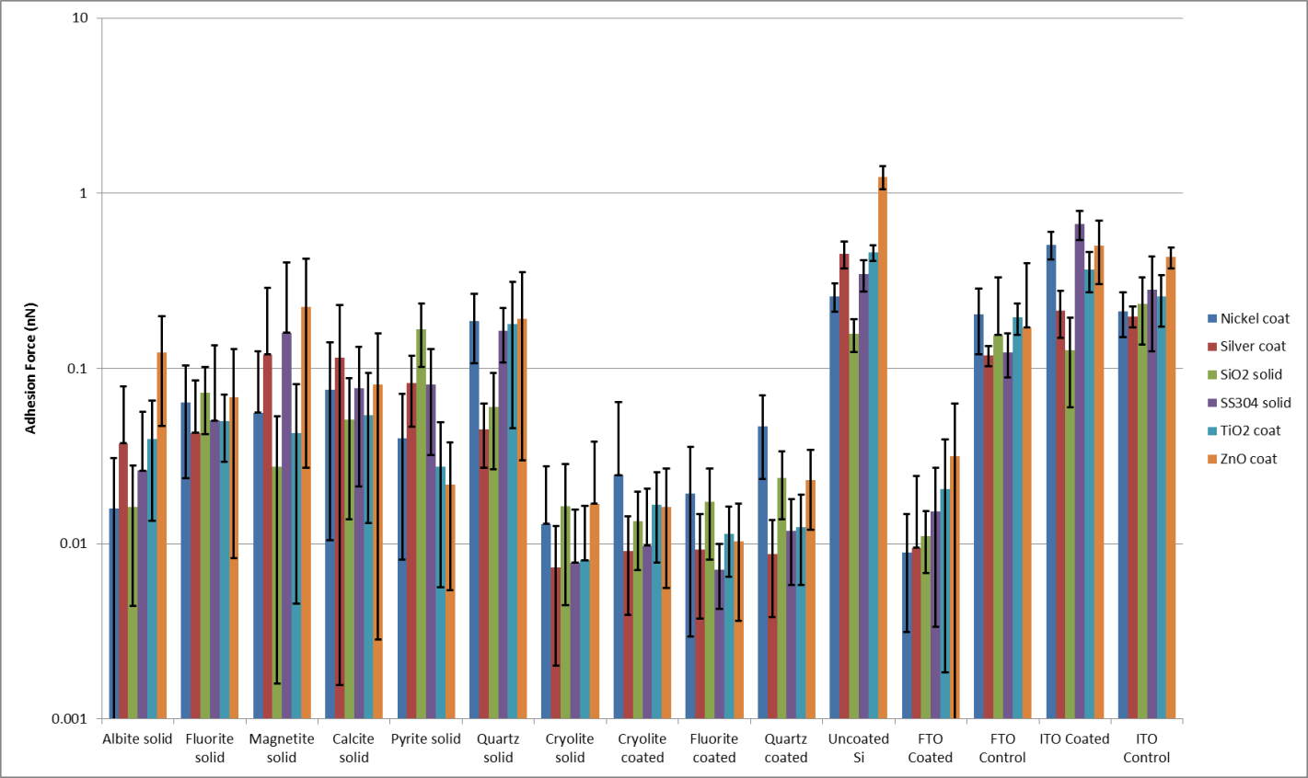

## Trends in FTO and glass substrates

FTO showed the lowest adhesive force of the glass substrates, comparable to the solid cryolite and coated Si wafers. ITO on the other hand was more sticky than the control (uncoated glass) samples. Thus there is clear evidence of the influence of Fluorine on reduced adhesion, which can be explored in theory. ZnO was stickiest on FTO, which corresponds to some statements by Evelyn Wang according to Mike.

## Trends in Si substrates

The coated substrates all showed reduced adhesive force as expected. All were well wetted by water (low contact angle). Two points of interest arise. First, the quartz and fluorite coated is less sticky than their solid counterparts (suggesting a different crystal structure in the coated Si wafer – should be explored in XDS), as opposed to cryolite coated and solid being similar. Second, the cryolite and fluorite coated wafers both experienced coating peeling, but the exposed spots after peeling in the fluorite wafer were sticky like uncoated Si while exposed spots after peeling in the cryolite wafer were NOT sticky (suggesting a thin coating remaining afterwards)! These effects should be more evident in the CRUD loop test.

## Trends in minerals

The minerals all showed low adhesion, though they were not in agreement with the earlier model. No quantitative analysis was done.

## Reproducibility between experiments and probes

Only two experiments used the same probes and substrates. Those measurements were very close.

# Matrix Modification

The highest uncertainty samples were removed, as well as difficult-to-align samples and visually/optically rough samples. This resulted in the following reduced matrix of substrates:

|  |  |  |
| --- | --- | --- |
| **Candidate substrates for removal:** | | |
| ITO Control | Use Si wafer as control | |
| FTO Control | Use Si wafer as control | |
|  | Replace coated wafers with new set S38 | |
| Magnetite | High stdev | |
| Fluorite | Impossible to tell when on mineral | |
| Pyrite | Very rough surface | |
| Albite | Impurities have measurable effect (evidenced by quick test in E109?) | |
|  |  | |
| **This leaves 9 total substrates for continuation:** | | |
| Calcite solid | |  |
| Cryolite coated | |  |
| Cryolite solid | |  |
| Fluorite coated | |  |
| FTO Coated | |  |
| ITO Coated | |  |
| Quartz coated | |  |
| Quartz solid | |  |
| Uncoated Si | |  |